System Design Plan

1. Location of system: See the System Diagram for system location

2. List of intended uses
The graywater system will be used to irrigate (list plants) during the irrigation season.

3. Fixtures entering system
(List fixture entering the graywater system)

4. Estimated graywater flow from fixtures ____________

Describe how you estimated the graywater production from each fixture. For example, “Shower (listed at 2gpm) x 2 showers per day x 6 minutes per shower = 24 gallons/day
+ Washer uses 15 gallon/load X 5 loads a week = 75 gallons/week or ~11gallons/day
Total graywater production = 11gpd + 24 gpd = 35 gpd”

5. Description of graywater system including any treatment, tanks, or filters.
Describe your graywater system including materials used. For example, “This is a laundry-to- landscape system which includes a diverter valve attached to the washer drain hose, an anti- siphon components (AAV), and 1 inch HDPE tubing in the landscape. Barbed reducing tees distribute water subsurface into mulch basins, located near the plants to be irrigated).

Graywater Irrigation Site Evaluation Report

1. Parcel size _________(List the parcel size)

2. Soil profile ________________(list the soil type, including how you determined it)
For example: According to the USDA Soil Survey website (websoilsurvey.sc.egov.usda.gov/) the soil type is sandy clay. An on-site soil ribbon test confirmed the soil to be sandy clay.

3. Infiltration rate of soil_____________________
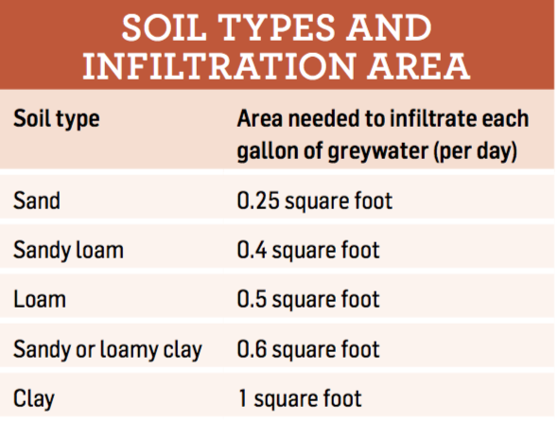

4. Required infiltration area (Gallons/day X infiltration rate)
For example: 35 gpd X 0.6 = 21 square feet
5. Water table levels (List water table level. If not known, dig a 4 foot test hole)
For example: No water was present in a 4 foot test hole.

6. Description of vegetation in the reuse area (List vegetation to be irrigated with the graywater system.)

7. Evapotranspiration rates for vegetation during the period of reuse
Evapotranspiration Rate (found at https://www.epa.gov/watersense/water-budget-data-finder)
Monthly ET______ Weekly ET (divide monthly by 4) ______
Species factor for plants (High water use plant 0.8, medium water use plan 0.5, low water use plant 0.2. To find species factor use reference such as Sunset Western Garden Book or CIMIS website.
Type of plant | Number of plants X | 0.62 X (constant) | Area of plant X (footprint) | Species factor X | ET for irrigation period = | Gallons/week

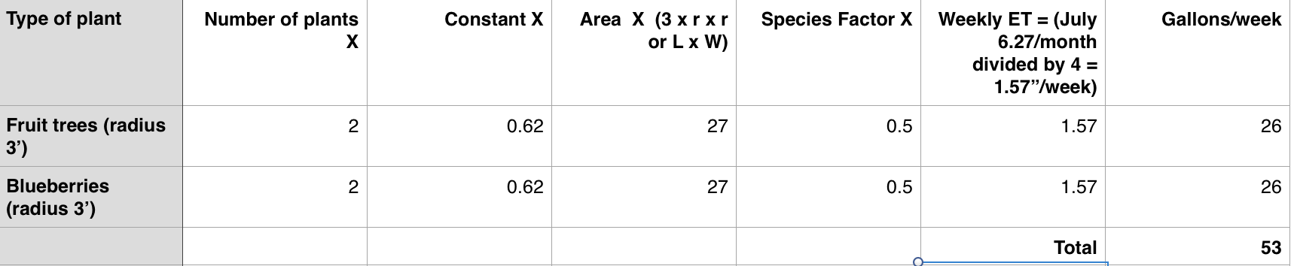
Example of how to find Evapotranspiration Rates

System Diagram
Using the graph below, indicate where on the property the graywater will be used (see sample site plan). Indicated area of reuse and slopes; setbacks to property lines, any surface water, wells, or springs; onsite wastewater systems; stormwater management systems (raingardens, stormdrains); and escarpment, cuts or fills.
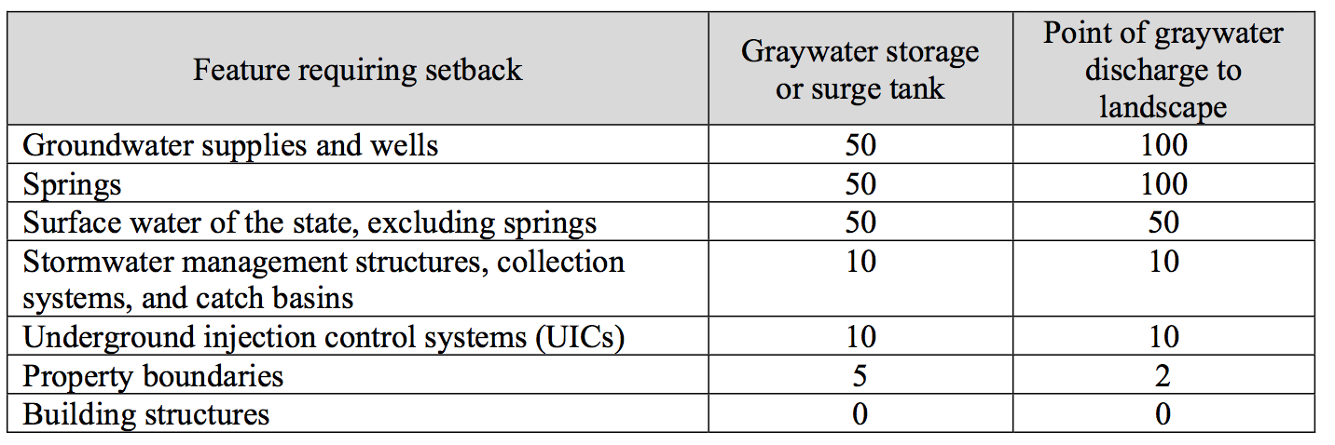

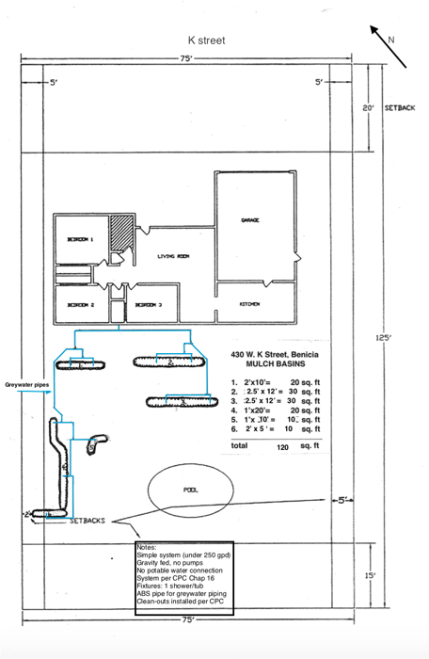
Example System Diagram
